PRESS RELEASE

Würth Elektronik: Digital WE Days – Virtual Conference from April 22 to 25, 2024
Expert Knowledge Online
Waldenburg (Germany), March 26, 2024 – The transfer of expertise is a fundamental element of Würth Elektronik's service concept. This includes in-depth expert presentations in digital format. As part of Digital WE Days, experts from Würth Elektronik and its partner companies will be presenting on important topics like intelligent power and control systems, EMC, electromechanics, wireless power, optoelectronics, and PCBs. Registration for the free event is now open at http://www.we-online.com/digital-we-days.
“Last year, more than 4,300 participants took advantage of our online service offerings,” says Alexander Gerfer, CTO at Würth Elektronik eiSos. “This shows that we are in touch with the times with our Digital WE Days. We are continuing this successful concept this year.”
From April 22 to 25, 2024, experts from Würth Elektronik, Rohde & Schwarz, onsemi, Infineon, Texas Instruments, Cambridge GaN Devices, Silent Solutions, as well as Wired & Wireless Technologies, will provide for a varied and high-caliber presentation program. A 30-minute presentation is followed by an interactive Q&A session lasting around a quarter of an hour, which further deepens the knowledge imparted in the expert presentation.
“We know the current market and technology trends as well as our customers,” Gerfer continues. “On this basis, we’ve once again put together an interesting and contemporary presentation program this year – from practitioners for practitioners.”
Registration now open
Digital WE Days 2024 is a free service from Würth Elektronik. All presentations can be booked individually. Registration for the virtual conference is now open.
Information on the presentation program, the individual topic areas and registration can be found at:
http://www.we-online.com/digital-we-days

Available images
The following images can be downloaded from the Internet in printable quality: https://kk.htcm.de/press-releases/wuerth/
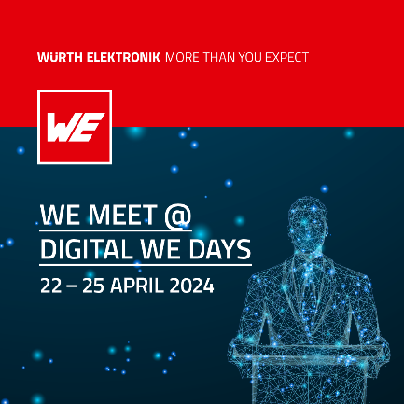Image source: Würth Elektronik  Digital WE Days – Virtual Conference from Würth Elektronik from April 22 to 25 | 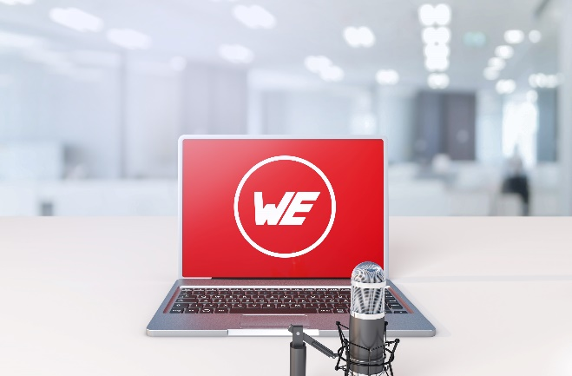  Image source: Würth Elektronik  At Digital WE Days, experts from Würth Elektronik and its partner companies will be presenting on topics like intelligent power and control systems, EMC, electromechanics, wireless power, optoelectronics and PCBs.

About the Würth Elektronik eiSos Group
Würth Elektronik eiSos Group is a manufacturer of electronic and electromechanical components for the electronics industry and a technology company that spearheads pioneering electronic solutions. Würth Elektronik eiSos is one of the largest European manufacturers of passive components and is active in 50 countries. Production sites in Europe, Asia and North America supply a growing number of customers worldwide.
The product range includes EMC components, inductors, transformers, RF components, varistors, capacitors, resistors, quartz crystals, oscillators, power modules, Wireless Power Transfer, LEDs, sensors, radio modules, connectors, power supply elements, switches, push-buttons, connection technology, fuse holders and solutions for wireless data transmission. The portfolio is complemented by customized solutions.
The unrivaled service orientation of the company is characterized by the availability of all catalog components from stock without minimum order quantity, free samples and extensive support through technical sales staff and selection tools.
Würth Elektronik is part of the Würth Group, the global market leader in the development, production, and sale of fastening and assembly materials, and employs 7,900 people. In 2023, the Würth Elektronik Group generated sales of 1.24 Billion Euro.
Würth Elektronik: more than you expect!
Further information at www.we-online.com

Further information:  Würth Elektronik eiSos GmbH & Co. KG  Sarah Hurst  Clarita-Bernhard-Strasse 9  81249 Munich  Germany  Phone: +49 7942 945-5186  E-mail: sarah.hurst@we-online.de  www.we-online.com | Press contact:  HighTech communications GmbH  Brigitte Basilio  Brunhamstrasse 21  81249 Munich  Germany  Phone: +49 89 500778-20  E-mail: b.basilio@htcm.de  www.htcm.de

